RESULTS LSTM CATEGORY BASED MAMS DATASET

1. MAMS(ACSA)

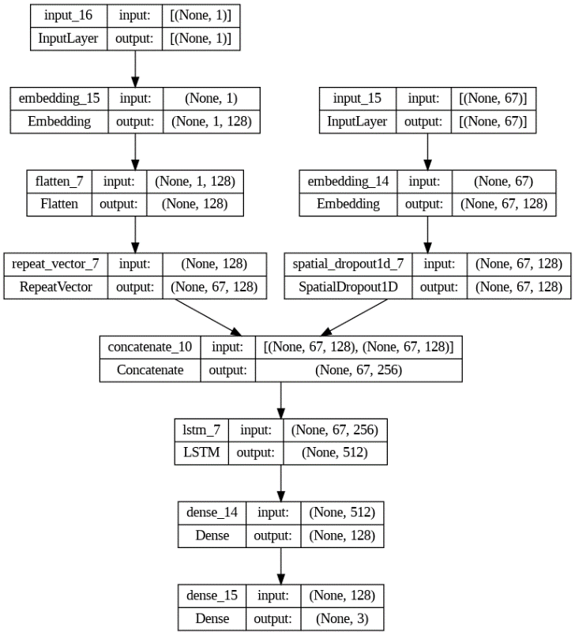Model summary:  
  
## LSTM with Aspect Embedding:

learning_rate_reduction = ReduceLROnPlateau(monitor='val_accuracy',

                                                    patience = 2,

                                                    verbose=1,

                                                    factor=0.1,

                                                    min_lr=0.000001)

from tensorflow import keras

opt = keras.optimizers.Adam(learning_rate=0.01)

ae_lstm_model.compile(loss='sparse_categorical_crossentropy', metrics=['accuracy'], optimizer=opt)

history =  ae_lstm_model.fit(x = train_data, y = y_train, validation_data = (val_data, y_val), batch_size=16, epochs=20, callbacks = [learning_rate_reduction])

Accuracy:  
Train: 78%

Test: 57.26%

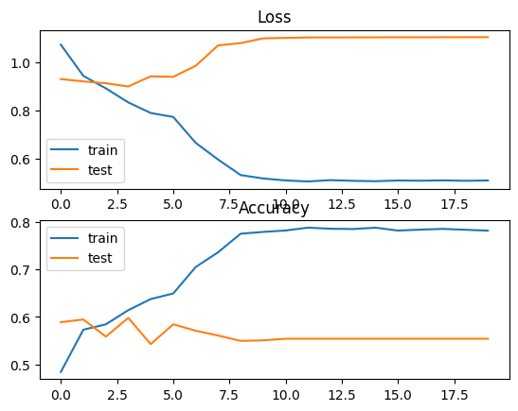

Attention-based LSTM (AT-LSTM)

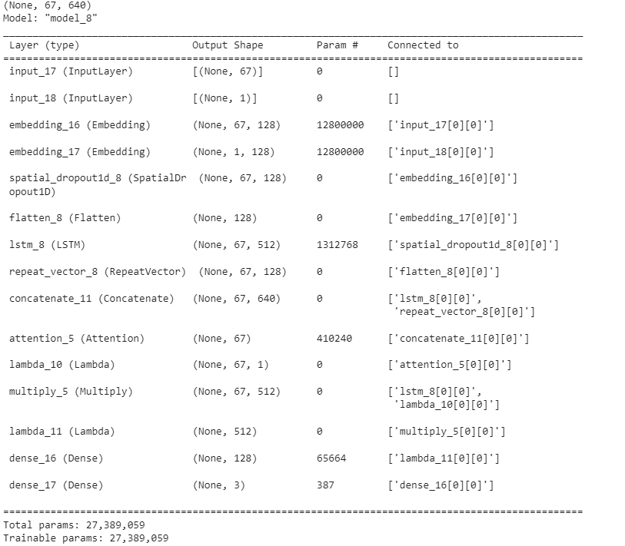

learning_rate_reduction = ReduceLROnPlateau(monitor='val_accuracy',

                                                    patience = 1,

                                                    verbose=1,

                                                    factor=0.1,

                                                    min_lr=0.000001)

opt = keras.optimizers.Adam(learning_rate=0.01)

at_lstm_model.compile(loss='sparse_categorical_crossentropy', metrics=['accuracy'], optimizer=opt)

at_lstm_model .fit(x = train_data, y = y_train, validation_data = (val_data, y_val), batch_size=32, epochs=20, callbacks = [learning_rate_reduction])



Accuracy:  
Train: 57%

Test: 59%

Attention-based LSTM with Aspect Embedding (ATAE-LSTM)

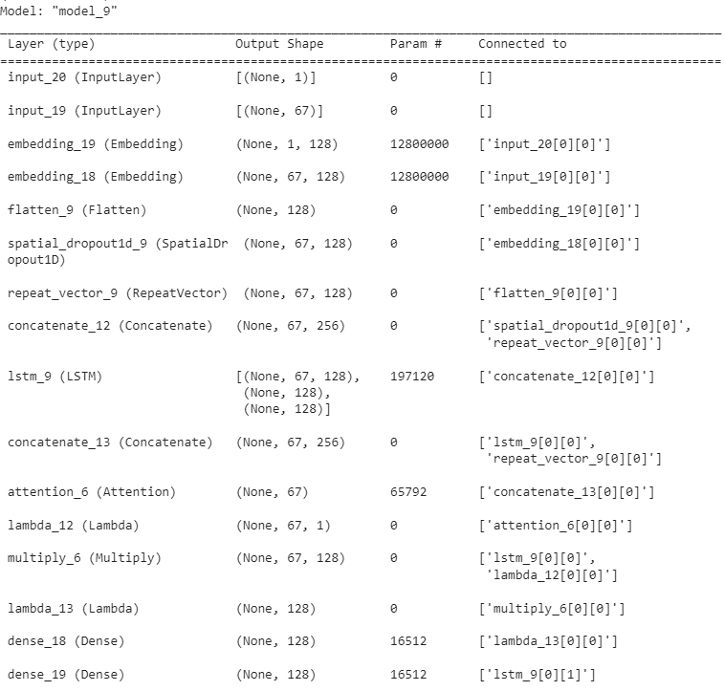

learning_rate_reduction = ReduceLROnPlateau(monitor='val_accuracy',

                                                    patience = 2,

                                                    verbose=1,

                                                    factor=0.1,

                                                    min_lr=0.000001)

atae_lstm_model.compile(loss='sparse_categorical_crossentropy', metrics=['accuracy'], optimizer='adam')

atae_lstm_model .fit(x = train_data, y = y_train, validation_data = (val_data, y_val), batch_size=32, epochs=20, callbacks = [learning_rate_reduction])

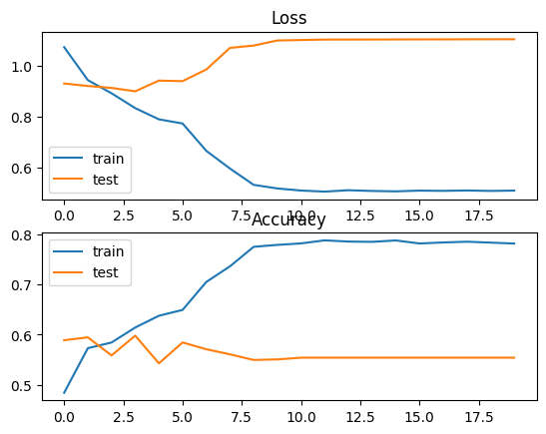

Accuracy:  
Train: 70%

Test: 62.81%

RESULTS LSTM CATEGORY BASED SENTIHOOD DATASET

NOTE: MODEL SUMMARY SIMILAR TO THE MAMS DATASET

1. ## LSTM with Aspect Embedding:

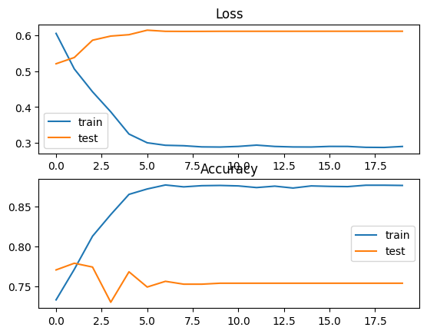

Accuracies:

Train: 87%

Test 75.75%

Attention-based LSTM (AT-LSTM)



Accuracies:  
Train: 83%

Test: 76%

Attention-based LSTM with Aspect Embedding (ATAE-LSTM



Accuracies:

Train: 90%

Test: 80%

SEMEVAL LAPTOP DATASET

LSTM with Aspect Embedding

learning_rate_reduction = ReduceLROnPlateau(monitor='val_accuracy',

                                                    patience = 2,

                                                    verbose=1,

                                                    factor=0.1,

                                                    min_lr=0.000001)

from tensorflow import keras

opt = keras.optimizers.Adam(learning_rate=0.01)

ae_lstm_model.compile(loss='sparse_categorical_crossentropy', metrics=['accuracy'], optimizer=opt)

history =  ae_lstm_model.fit(x = train_data, y = y_train, validation_data = (val_data, y_val), batch_size=16, epochs=20, callbacks = [learning_rate_reduction])

Evaluate on test data

26/26 [==============================] - 1s 10ms/step - loss: 1.2348 - accuracy: 0.6742

test loss, test acc: [1.2348250150680542, 0.6741573214530945]

Accuracy of the model is - 67.41573214530945 %

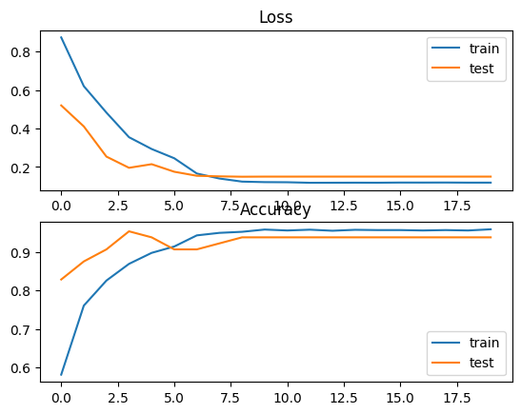

Attention-based LSTM (AT-LSTM)

learning_rate_reduction = ReduceLROnPlateau(monitor='val_accuracy',

                                                    patience = 2,

                                                    verbose=1,

                                                    factor=0.1,

                                                    min_lr=0.000001)

opt = keras.optimizers.Adam(learning_rate=0.01)

at_lstm_model.compile(loss='sparse_categorical_crossentropy', metrics=['accuracy'], optimizer=opt)

at_lstm_model .fit(x = train_data, y = y_train, validation_data = (val_data, y_val), batch_size=16, epochs=20, callbacks = [learning_rate_reduction])

Evaluate on test data

26/26 [==============================] - 1s 14ms/step - loss: 0.8398 - accuracy: 0.6005

test loss, test acc: [0.8397857546806335, 0.6004993915557861]

Accuracy of the model is - 60.04993915557861 %



Attention-based LSTM with Aspect Embedding (ATAE-LSTM

learning_rate_reduction = ReduceLROnPlateau(monitor='val_accuracy',

                                                    patience = 2,

                                                    verbose=1,

                                                    factor=0.1,

                                                    min_lr=0.000001)

atae_lstm_model.compile(loss='sparse_categorical_crossentropy', metrics=['accuracy'], optimizer='adam')

atae_lstm_model .fit(x = train_data, y = y_train, validation_data = (val_data, y_val), batch_size=16, epochs=20, callbacks = [learning_rate_reduction])

Evaluate on test data

26/26 [==============================] - 1s 9ms/step - loss: 2.8083 - accuracy: 0.6754

test loss, test acc: [2.808305025100708, 0.675405740737915]

Accuracy of the model is - 67.5405740737915 %

CodeText



SEMEVAL RESTAURANT DATASET

LSTM with Aspect Embedding

Evaluate on test data

27/27 [==============================] - 0s 9ms/step - loss: 0.7260 - accuracy: 0.7334

test loss, test acc: [0.7260186672210693, 0.7334109544754028]

Accuracy of the model is - 73.34109544754028 %

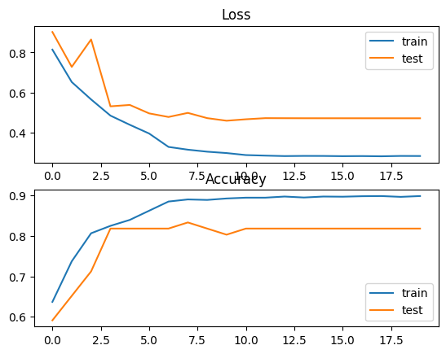

Attention-based LSTM (AT-LSTM)

Evaluate on test data

27/27 [==============================] - 0s 9ms/step - loss: 0.7260 - accuracy: 0.7334

test loss, test acc: [0.7260186672210693, 0.7334109544754028]

Accuracy of the model is - 73.34109544754028 %



Attention-based LSTM with Aspect Embedding (ATAE-LSTM

Evaluate on test data

Evaluate on test data

27/27 [==============================] - 0s 5ms/step - loss: 2.0508 - accuracy: 0.7427

test loss, test acc: [2.0507540702819824, 0.7427241206169128]

Accuracy of the model is - 74.27241206169128 %

